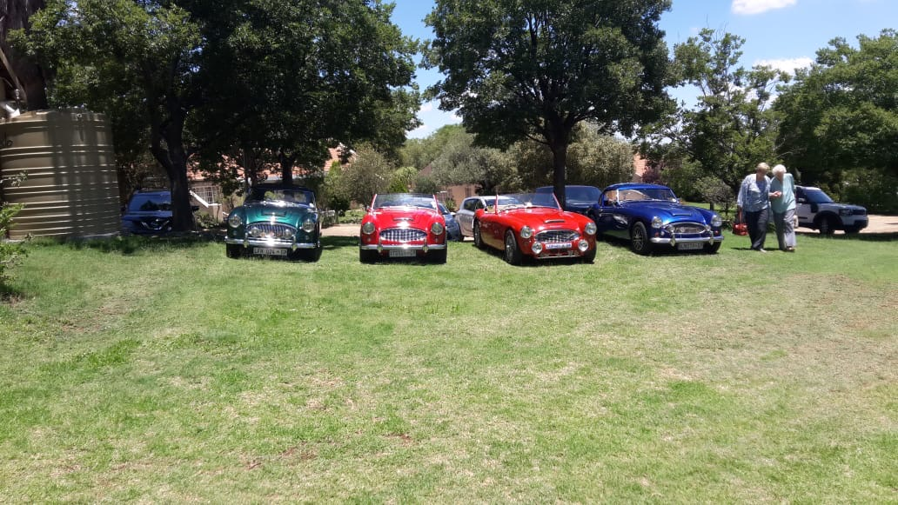
Ho Ho Ho ---- Austin Healey Club Gauteng - Christmas Lunch

It’s nearly Christmas again and Gauteng’s Healey owners (and some who aren’t) met for another fabulous Christmas lunch.

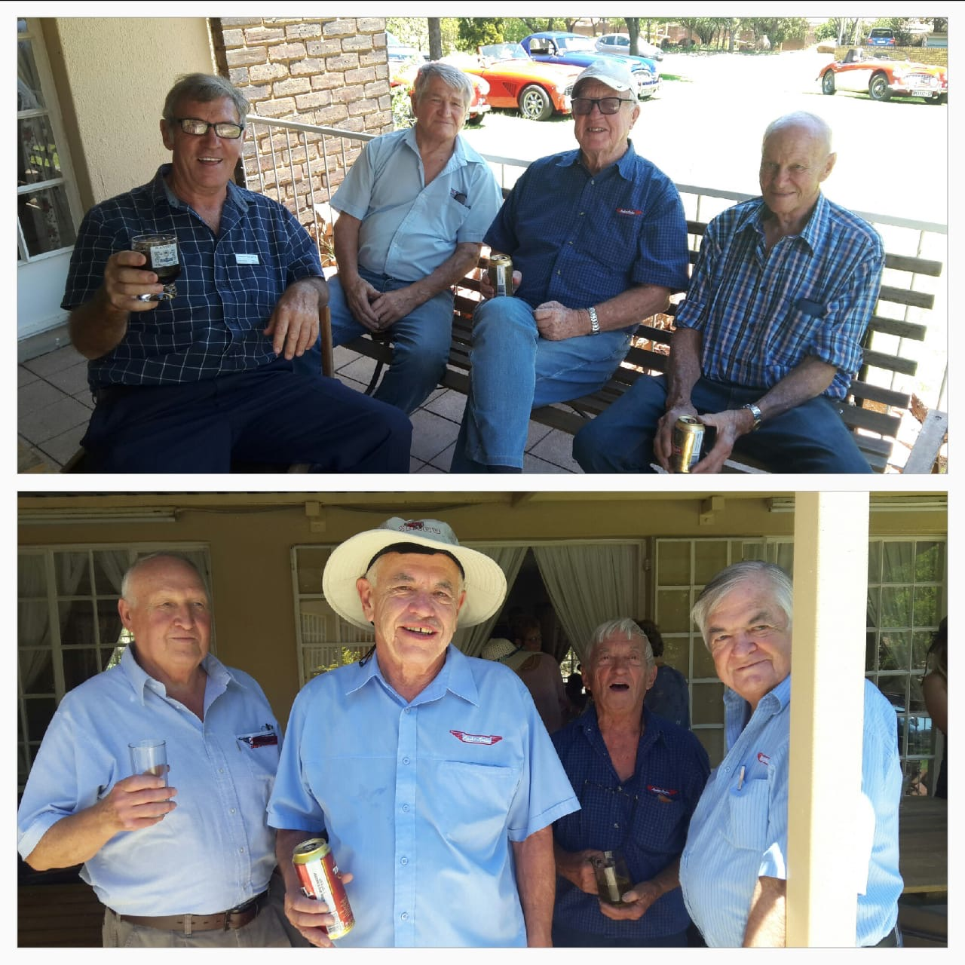
The occasion started with enthusiastic hellos and much hugging, kissing, smiling, laughing and “can you believe it’s almost Christmas again”. Oh – and for some weird reason all the men had some sort of cosmic connection whilst getting dressed to go out and play with their Healeys…..they all donned blue shirts ! Seriously – look at the picture !!

After all the fabulous Healeys were parked outside the venue in the Renaissance Retirement Village, the party started…and what a wonderful treat it was.

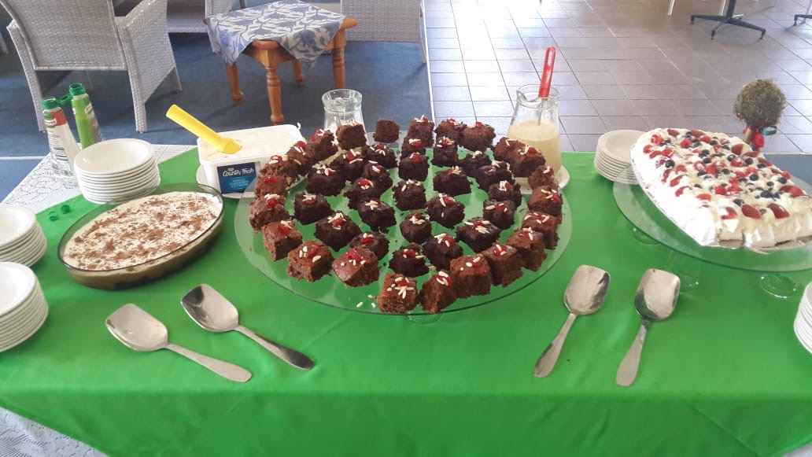
Once again the fabulous Marti and her team laid on the most spectacular lunch…..beef, lamb AND pork, roast potatoes and salad. Then came the deserts !!! Just take a look at the photo! What a great start to the Christmas gastronomic over-indulgence.

As usual, this annual get-together was a wonderful opportunity for the boys to compare Healey knowledge and information, and for the girls to catch up and laugh at the boy’s car obsession !! Some of the boys start younger than others!!!!

Thank you Mara for organizing this year’s Christmas occasion.

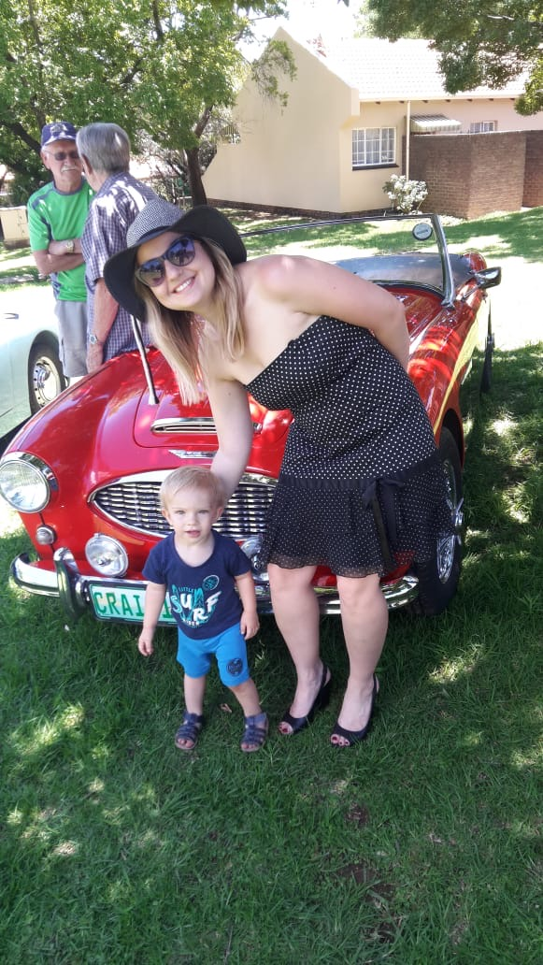

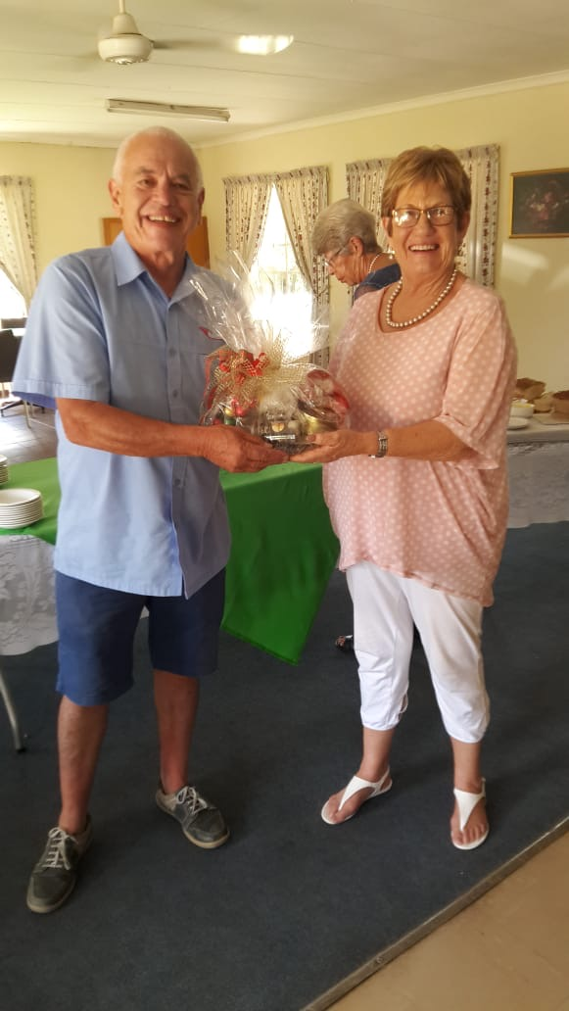
Thank you Marti for spoiling us……. and our diets. !

