VEHICLE AUTO POLISHING
  - INTRODUCTION
The auto polishing process comes in various guises and these you will find below.
- Paint correction
- Rejuvenation
- Hand polishing
- After paint
- Weekend
With all these different guises, there are also a lot of different products………
- Meguiars
- Shield
- Auto Glym
- Menzerna
- Mothers
- 3 M
- Farelca
- Turtle wax
- Kenon
And this is just to name a few products that are out there on offer for the customer – and let’s not forget the machines themselves…..
- Rotary machines
- Dual action machines
These machines come in air or electric format with different variations in power and speed output, so be sure to pick the one that is going to suit your need, be it work or hobby.
I often get asked to polish a car in a certain look – WET LOOK – CLASSIC LOOK – HIGH GLOSS to name a few. Whilst there are products out there that do this, they fail to mention that there is a whole process to achieve these looks. I was once asked by a client to use a specific product to achieve an ocean look as on the picture in the product brochure, but I shouldn’t use a machine, but rather do it by hand……it did not matter what I explained to him about the process , the brochure said that the product gave it that look.. Needless to say, I passed on that particular project.
Television programs and the internet also do not help as 90% of the time they are done by people who have been in the industry for a long time and make it look easy and complete the project in no time at all. This is where your everyday/weekend enthusiast falls down and wastes money and effort.
In the next few chapter’s, I will try and simplify the various processes and give examples and tips.
  - REJUVENATION
This process does exactly what the name suggests – rejuvenates and brings back the paint work to an acceptable level and as close to original as possible without a full paint correction.
There are many levels and steps that are used for rejuvenation; it all depends on what the client’s expectations are and the condition of the vehicle. Usually, a rejuvenation would be a 1-3 step process and would suit the weekend hobbyist as it is not as complex as a full paint correction.
Restoring original and antique paint
with the internet and in interest in collecting cars, there’s a lot of interest in restoring and preserving original paint on classic and antique cars. Restoring the original paint maintains the overall originality of the complete car and adds to the value as long as the resulting finish is acceptable in appearance and represents how the vehicle would look for its age had the paint been properly maintained over the years.
Antique and older, single stage paints are usually some type of lacquer or enamel and these paints are prone to oxidation when exposed to air and moisture over time. Oxidation is where the paint deteriorates by coming apart or disintegrating. This usually shows up as a chalky whitish looking colour on the surface of the paint even if the paint was originally some other colour besides white. Just to note, white paint will oxidize too but because it’s the same colour as the chalky white oxidization you have to look carefully to see it. Oxidized white paint can just look dull when it in fact is oxidized. Single stage, non-metallic paints like the paint on the Nissan below are actually very easy to correct, because the problem is just on the surface. All that has to be done is to remove the dead paint off the surface and if there's enough paint left then it's just a matter of polishing what's left to a high gloss.
The most difficult paints to restore are single stage metallic paints. This is because the metallic inside the paint actually oxidizes as well as the paint itself. 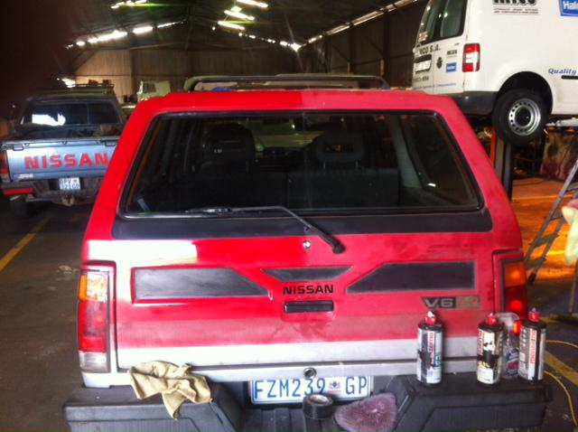
Typical oxidization and the result of a rejuvenation polish
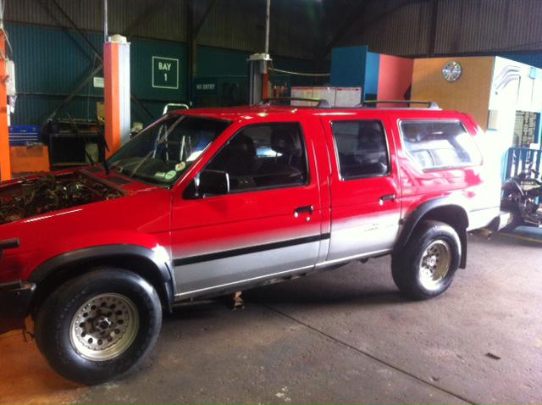
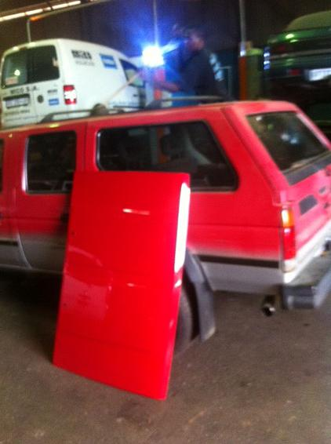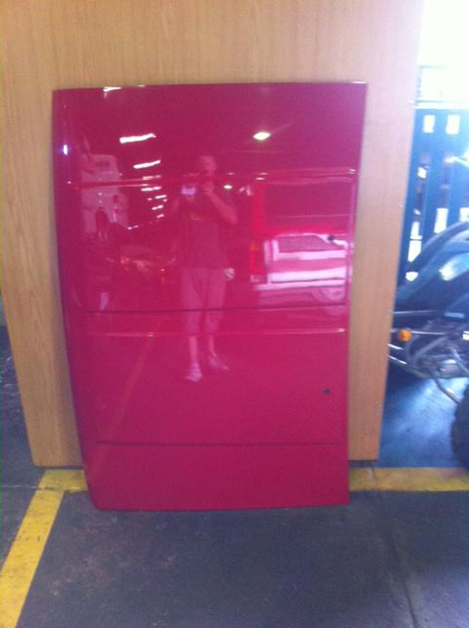
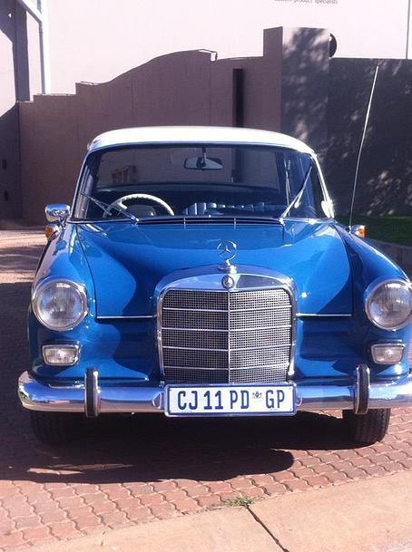
What to do
if preserving the original paint is important to you then the first thing you want to do is condition the paint before working on it. Most people just jump right in and start rubbing some type of abrasive compound over old, dry, fragile paint and this will remove a lot of paint quickly and possible remove too much. There are various products out there that do this and each are competitive, it’s how you use them more than the product itself, so take some time and research a few products.
- Wash the car – If the vehicle is a classic I would recommend a waterless wash, this prevents water from going into any cracks and causing rust damage. A waterless car wash is a lubricant spray detailer with a combination of gentle cleaning agents embodied in a high lubricant liquid that can be sprayed onto the paint and then gently wiped-off. This will enable you to remove any dust or loose surface dirt while reducing the potential to inflict swirls and scratches during the process.
- If the vehicle still has any contaminants to the touch, then I would recommend clay barring the vehicle.

- If the oxidization is not too bad then there are products out there that will bring it up with a little patience and some elbow grease, if not then the use of a machine will be required to bring it back to the acceptable level and colour.

- Once you have brought the vehicle up to the desired finish, then a wax or a sealant can be applied.

The key is to use the right equipment and products and also knowing your vehicle’s paint. To abrasive a product can cause more problems instead of fixing them.

  - PAINT CORRECTION
Overtime, dust – dirt and other contaminants build up on the surface of the vehicle. If you look at the surface of your vehicle, visually it looks smooth, but rub the back of your hand along it and you will feel the imperfections in the clear coat.
Washing your vehicle gives the look of a nice, clean vehicle. What it is actually doing is scratching the clear coat by turning the dust particles that exist on your vehicle into a form of sandpaper, the more you wash, the more it scratches your vehicle. Overtime, these scratches cause the paint work to become dull and hazy.
Paint correction is the use of specialised machines, polishing agents and most importantly, technique……you can buy any machine and agent, but without the technique it will be a pointless exercise. The paint correction process slowly removes layers in the paint work (clear coat) to once again make the surface smooth and mirror like.
THE USUAL SUSPECTS IN PAINT DEFECTS AND IMPERFECTIONS
- Scratches
- Cob web effect
- Machine swirls (holograms)
- Oxidisation
- Chemical etching
- Bird droppings
- Rain spots
When waxing your vehicle, think of it as make up for your car. You can apply was either by hand or by machine. Basically, all it does is fill in the scratches and imperfections that are visible, making them harder to see and giving a false effect. With washing and time, the wax dissipates and reveals all the old imperfections and scratches. In terms of paint correction, waxing is purely cosmetic and does nothing to remove defects in the paint work.
Removing the defects requires the slow removal of layers (as mentioned previously). Compounding agents are specifically formulated, so that when used in conjunction with a polishing pad, it acts as a very fine form of sand paper that shaves the surface area. Once this process is complete and the paint work has been brought back, a polish is then applied to remove any holograms/hazing whilst at the same time adding depth to the surface. Using the right polish/compounds and the right pads is a very important part of the process.
Now that the paint work is back to its former glory, it is now ready for a protective coating. Waxes and sealants can be applied, but offer very different types of protection. A paint sealant is a synthetic polymer that will last longer (between 6 & 12 months) depending on products. Sealants have basically taken over from wax as they can now offer the gloss and deep shine effects that waxes were/are renowned for.
THE PROCESS OF PAINT CORRECTION.
- Wash process and clay bar
- Most people think that when a car is washed it is clean. It might be to the naked eye and it has removed the major contaminants, but 9 times out of 10 you will find that there are stubborn little contaminants left. This is where the clay bar comes into its own. Using a special clay lubricant with a soft detailing clay bar, go over the entire surface thoroughly. This process allows the clay to pick up any leftover contaminants. This is a very small but important process. If you start polishing and some contaminants are left, the polishing process can grind them into the paint work.
- Wet sanding
- Sometimes, simply machine polishing is not enough. Stubborn scratches, orange peel will require wet sanding. This process takes off a minute layer of the top coat, thus removing the scratches etc. This process then requires an extensive machine polishing process to bring the shine back to the paint work.
- Buffing and polishing
- This step of the process is the actual polishing of the paint work. It is not as easy as it sounds or how it is portrayed online. It will depend on a number of factors to find out the exact process to use, such as the amount of clear coat, if it is a 1 stage paint and also the severity of the imperfections themselves.. So, the combination of machine pads and polish can differ from vehicle to vehicle. An example of this would be wet sanding. This would take a multistep process which would include the use of 3-4 different correction pads, 3-4 for polishing pads and also a variety of different polishing pastes/compounds. Always remember that whilst you are removing scratches and imperfections with the 1st stage of this process, you are also creating light scratches and these will only be removed in the final stages.
- Sealing and waxing
- There are a lot of products on the market for this final process, so please do your homework and pick the one that will suit your vehicle’s needs. A lot of detailers and enthusiasts like to use a glaze. This is a quick fix. All a glaze does is fill in scratches and imperfections, giving the false look of a “corrected paint”job. After a few washes and a couple of weeks, the paint work will revert back to its prior condition.
Synthetic polymer based sealants and Carnauba waxes are the best ton use. Sealants last a lot longer than waxes and waxes are supposed to give the best shine, but with advances in technology, sealants can also offer you the depth of shine required.

Paint correcting is a technique – done correctly and with the right products and tools can enhance the look of your vehicle.

For this type of work I would recommend that you take your vehicle to a qualified and reliable vendor.

Spider/cobweb effect After polishing
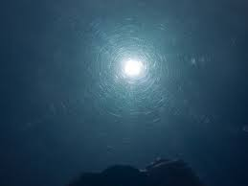
As you can see, the image on theleft has a very distinct cobweb effect. By using a machine and a bit of elbow grease, we managed to get it to a decent finish…… Not quite, if you look closely to the image on the right, you can see that there is still slight cobwebbing throughout.

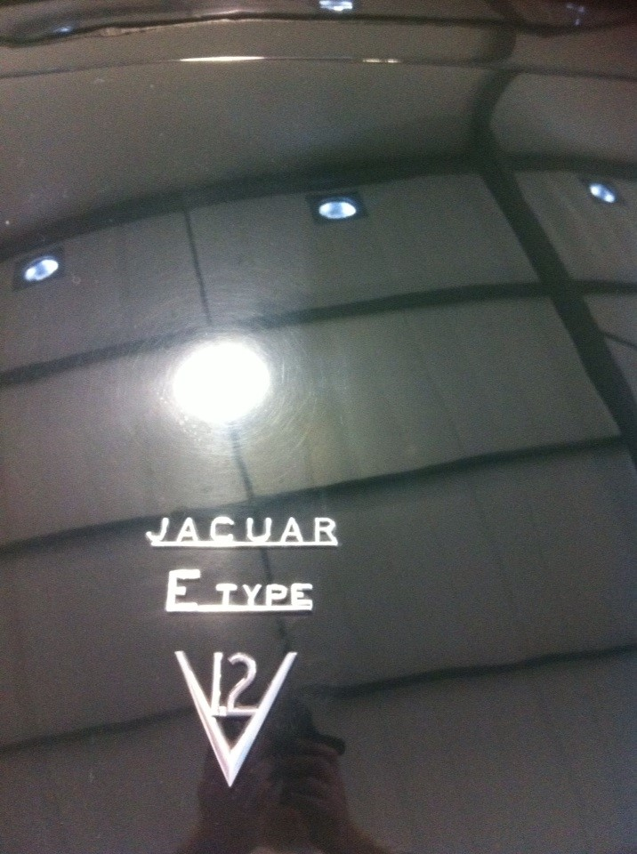
With this vehicle I simply put a strip of masking tape right down the middle of the boot lid. The owner of the vehicle has just finished “correcting” the vehicle………With the right tools and application we got the right side to come back to life. These images are pre wax/sealant.

